WORD PUZZLE
Directions: Please read the questions below and fill in the answer in the boxes across or down accordingly. Hope you have fun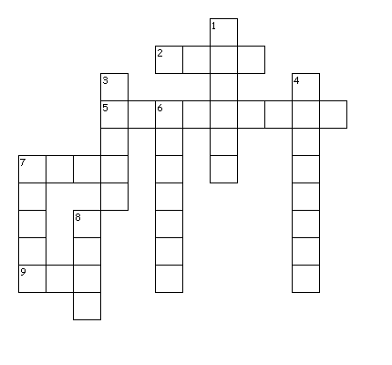
Across
2. What number is the product of (3 X 0 =) ?
5. What type of animal (like alligators and frogs) can live on either land or in water ?
7. What number is the sum of (2 +2 =) ?
9. What is (2 X 1 =) ?

Down
1. What food group does cereal, bread, and oatmeal, belong to?
3. What food group does milk, cheese, and yogurt belong to?
4. What is the name of an animal that has a pouch and typically hops on two legs?
6. What food group does peanut butter, turkey, and hummus belong to ?
7. What type of healthy food are apples, oranges, and pears, a type of ?
8. What is another name for a toad ?

Healthy Snack Recipe Corner!
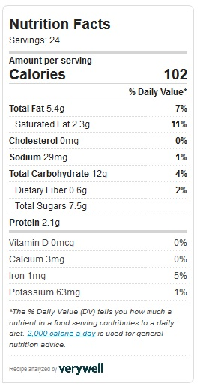
Peanut Butter Chocolate Chip Energy Ball
By Pialee Roy

Prep time: 10 mins
Total time: 10 mins
Serves: 24
Serving size: 1
Hope you enjoy this no bake recipe on its own or
with a half of a small apple and/or half of a small
banana!

You will need:
1. to wash your hands with soap and water,
then get:
2. a measuring cup for dry ingredients
3. a medium size bowl
4. 1 tablespoon, and
5. 1 teaspoon

Ingredients
- ½ cup creamy peanut butter
- ½ cup semi-sweet chocolate chips
- ½ cup raisins
- ½ cup whole grain honey nut oat cereal
- 2 tablespoons of honey

Instructions
- Combine all ingredients in a medium bowl.
- Stir to combine.
- Place in the refrigerator for 15 minutes
- Scoop the mixture onto a teaspoon and then drop onto your hands and roll into spheres and repeat the process to create 24 spheres
- Enjoy your snack then, or
- Store the remainder in the fridge for up to a week

Half of a Small Apple Half of a Small Banana

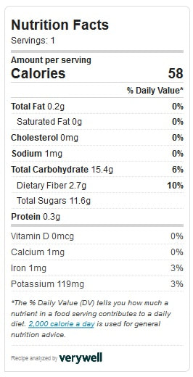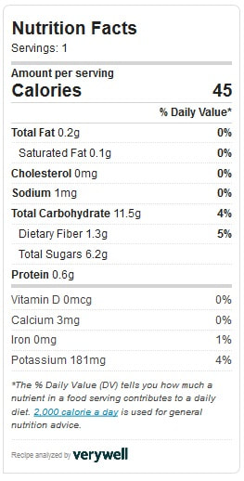
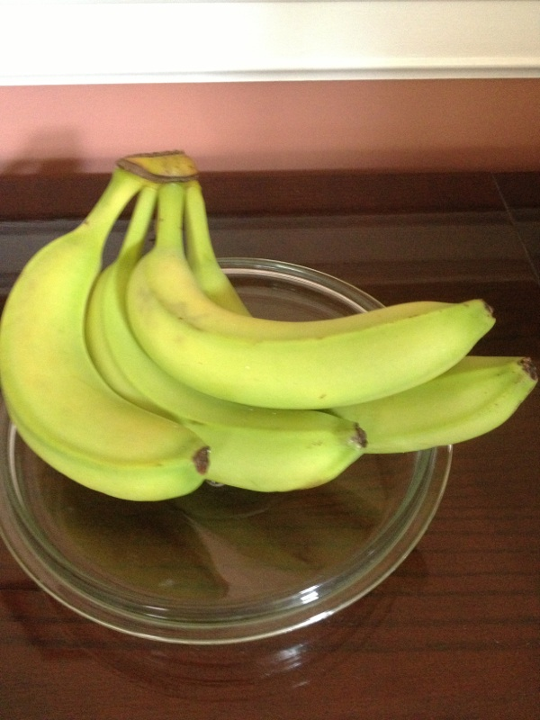
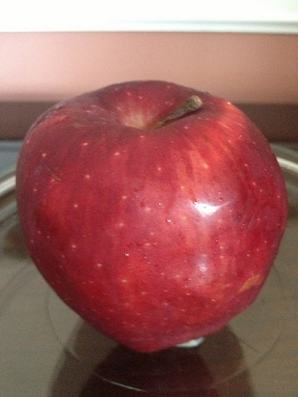

Math Fun Fact!
Any number multiplied by one is equal to that number. For example, five multiplied by one equals five and six multiplied by one is equal to six.
(5 x 1 = 5), (6 x 1 = 6), etc.
Now you can try:
8 x 1 = ? ________
32 x 1 = ? ________
144 x 1 = ? ________

Another Math Fun Fact!
Any number mulitiplied by zero is equal to zero. For example, five multiplied by zero equals zero and six multiplied by zero is equal to zero also.
(5 x 0 = 0), (6 x 0 = 0), etc.
Now you can try:
8 x 0 = ? _______
32 x 0 = ? _______
144 x 0 = ? ______

English Language Fun Facts!
- Words that rhyme sound alike.
- Homonyms are words that sound alike but have different meanings. Examples are listed below:
Bow = a ribbon tied decoratively or Bough = branch of a tree

Real =something actual and not fake or Reel = a circular collection of string

Male = a boy or man or Mail = deliveries of items in envelopes, packages,
or boxes sent from one household
to another household.

Now, can you match the correct homonym for the following words? Please circle the correct answer:
Phew ____________ Answer choices: To / Few / Rue / Sue
Sea _____________ Answer choices: See/ Fee/ Me/ We
Tea _____________ Answer choices: Free/ Leaf/ Tee/ Cup

Now, sound out the words in the answer choices out loud. Which words rhyme and which words rhyme with the main word on the left from the previous list? Can you find the two words that do not rhyme?
1.)________________ 2.) __________________

Good Job!

Jokes Corner
(Overheard)
Person 1: Be careful about parking near the frog pond!

Person 2: Why?
Person 1: You might get towed/ “toad”!
Person 2: Very funny.
Person 1: Ha ha ha!
----------------------------
Question: What is the best season to jump on a trampoline?
Answer: Spring time.
---------------------------
Question: What is orange and sounds like a parrot?
Answer: A carrot.
----------------------------
Question: What happens when a cat wins a dog show?
Answer: A cat-has-trophy! (Catastrophe)

(More Kids Jokes are available from https://short-funny.com/kids-jokes.php)
Safety Warning: Please ask permission to look up information on the internet, including information about jokes. Some jokes are simply not funny or appropriate. Thank you!

Number Counting!
How many of each of the following colors of candy pieces can you find?
Green? _______
Purple? _______
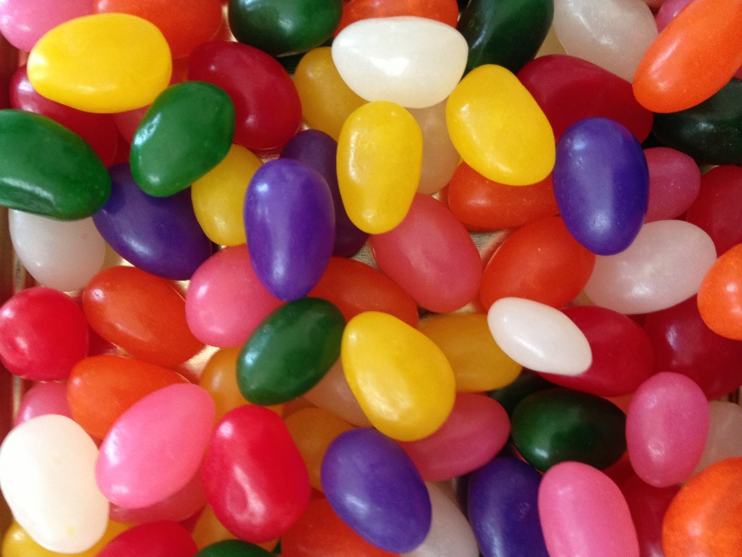

Science Experiment: Learning about Primary and Secondary Colors!
Research Question: How can you make secondary colors: Purple, Orange, and Green?
What you’ll need:
- Water
- Food coloring for primary colors: Red, Blue, Yellow
- Small paper or foam cups.
- Spoon for mixing
- Crayons
Safety: Please do not drink this water! Please ask for an adult to supervise.
Instructions: Fill at least 6 cups with half a cup of water.
  - Place a droplet of Red in two cups
What color does the water become if you add blue droplets to one of these two cups; and yellow droplets to the other?
  - Now, place a droplet of Blue in two new water cups
What color does the water become if you add red droplets to one of these
two cups?; and yellow to the other?
  - Color the circles with crayons below according to your results!
  - For clean up, please throw away the liquid mixtures in the kitchen sink and throw away the paper or foam cups in a garbage can. Thank you.

Red + Yellow = ?
Blue + Yellow = ?
Blue + Red = ?
Red + Blue = ?
Blue
Red

